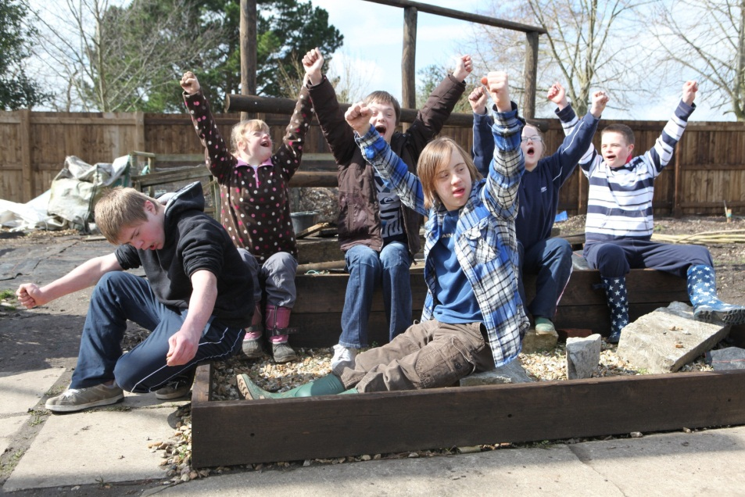

**Behaviour**

*By David Cudworth*

*Specialist Advisory Teacher, Ups and Downs Southwest 2011*

There are no behaviour traits peculiar to Down syndrome. There is no such thing as a “Down syndrome child”. There is nothing that children with Down syndrome do that other children do not do also, and there is nothing that children with DS do that has not been done already by other typically developing children. Stereotypical behaviours of being “stubborn but affectionate” have nothing to do with having an extra chromosome - they are, in fact, learned behaviours.

*“Children with Down syndrome are not born with any type of behaviours, but they are more vulnerable to acquiring them, due to the nature of their challenges. They are, however, born with an innate ability to be socially successful, as long as they are given the tools along the way…”*

(Victoria Ralfs, Ups and Downs Southwest Education Officer)

Behaviour matters because a person’s behaviour affects how other people behave towards them. It affects their levels of happiness, their opportunities and their quality of life. It affects their friendships and relationships. And it affects how they will get on in society, in employment and in living independently. Someone who has strong social skills will be much more easily accepted by others in “mainstream” society. Behaviour in children with DS is only inappropriate really if it interferes with their learning or happiness, or that of other children. Someone with Down syndrome who exhibits inappropriate behaviour will have difficulty in all aspects of their life.

Any behaviour problems exhibited in mainstream schools tend to be described as “insignificant” rather than “moderate” or “severe”. This is due, in our experience, to mainstream schools offering a peer group that displays age-appropriate behaviour and having higher expectations for behaviour. Most teenagers with DS do not display behaviour problems.

Differentiating the curriculum is rarely the issue for mainstream placements succeeding or failing. In almost all cases where placements have failed, it is due to behaviour problems, which are mainly a result of how the children are treated by others. Inappropriate behaviours in children with Down syndrome may occur by chance, but they reoccur due to the kind of “rewards” the children receive. All children, but particularly those with Down syndrome, will behave in a certain way to get a reaction or reward. So, if from an early age being over affectionate and tactile has been encouraged because the child with DS is very cute, it is unreasonable to expect the child to realise at fourteen years old that hugging the head teacher is not the done thing!

It is easy to underestimate the effort required for a pupil with DS just to get through a normal school day. This means that they can become very skilled at avoidance, and that they learn very early on which behaviours work and whose buttons they can press. Although some allowances will need to be made for the pupil’s emotional immaturity, expectations of good age-appropriate behaviour should remain high. Having Down syndrome does not give them an excuse to get out of things they do not like. It is no good being too soft on someone with Down syndrome – Down syndrome is not a soft issue.

Pupils with DS look up to and respect figures of authority and they have an uncanny ability to suss out who has got *“MUG”* written on their forehead! They are also very often fond, trusting and respectful of adults, and so have a strong desire to please and do not like being ignored. As a result, the rewards and sanctions they get from adults are a very powerful influence on their behaviour. If undesirable behaviour results in being ignored and “good” behaviour is rewarded with positive attention, they will soon learn that certain behaviour will have unpleasant outcomes and certain others will have pleasing consequences. Likewise, if good behaviour is taken for granted and undesirable behaviour is “rewarded” with attention, the pupil will display more inappropriate behaviour. It is important, then, to make only the good behaviour worthwhile.

So, **be consistent, be assertive**.

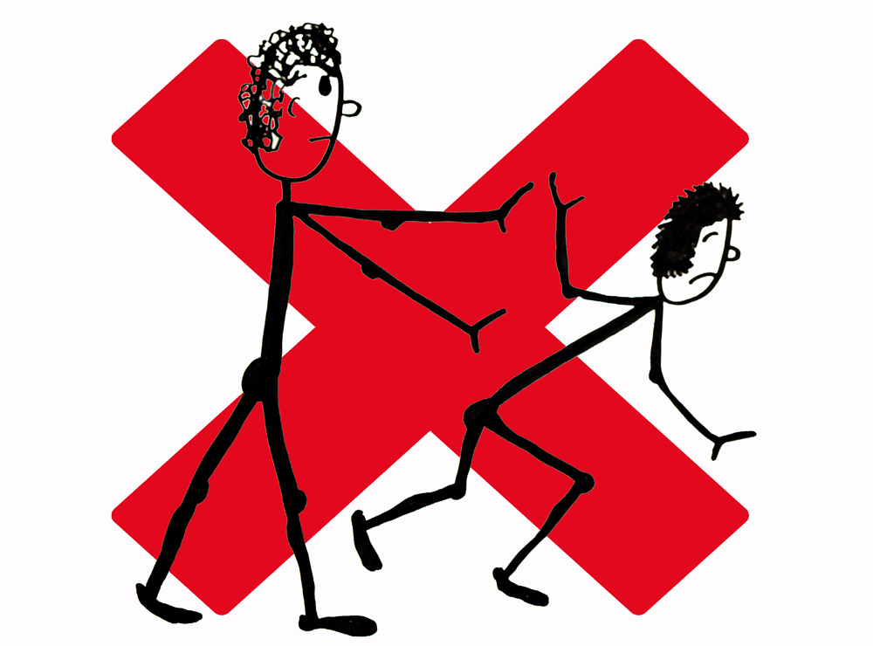

**Common Causes for Inappropriate Behaviour**

**Attention Seeking**

We all like attention. Children with Down syndrome are sociable beings, so they particularly like attention, and they constantly get a lot of attention from those around them. They may have become used to getting special treatment and so object when it is taken away. They may have become used to having an adult by their side all the time and resent her working with other children. They may, then, dislike waiting or being ignored, or resent it when they are not the centre of attention. They might have seen others getting what they want by misbehaving, or used attention-seeking in the past to get what they want.

**Anger or Frustration**

Sometimes the work given to children with Down syndrome is too easy, too difficult or boring. You cannot blame them, then, for reacting to that! Most children with DS want to be the same as everybody else and do not like being given different work or being withdrawn from class. They do not like to be made to seem to be different. Many adults also do not fully appreciate how hard it is having a disability. People with disabilities can get angry the same as anyone can, but often they cannot say why. Someone with DS may get annoyed when they think that other people are not listening to what they are trying to say.

**Confusion or Uncertainty**

Children with Down syndrome have learning difficulties, so they sometimes fail to understand the instructions they have been given. They also have short auditory memories, so may forget what has been said. Different people can often give conflicting messages, and rules and expectations often vary from one adult to another even within the same school, or between school and home. It is unfair to assume that children with DS know about rules and routines instinctively…They do not! Many children with DS lack the language and cognitive flexibility to negotiate and win a verbal argument. Anyone who is in a situation where they do not understand what is going on and is unsure of what people are trying to get them to do might resist and then be seen as stubborn. If not coerced positively, there can then be a knock-on effect on the child’s level of cooperation in future situations.

**A Need to Control** 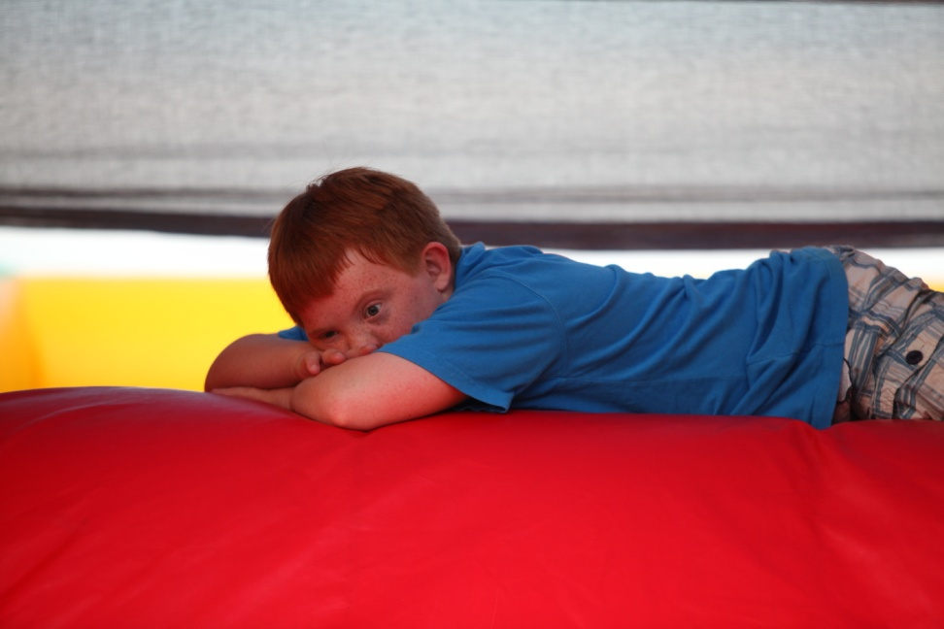

Sometimes a person with Down syndrome will refuse to cooperate through matter of principle, especially if they are seldom given the opportunity to choose or express a preference. Sometimes they feel under pressure and need a break. Learning is not just more difficult for them, it is also more tiring. Often being with a TA all day is enough to cause them to rebel! They may resent being withdrawn from class and being separated from their peers. The average child with Down syndrome does more work 1-1 with a TA than any of the other children. They may need a break.

**Immaturity**

Many children with Down syndrome lack age-appropriate play or social skills, and they need to be taught the skills to play cooperatively. Sometimes, schools place the child with DS with immature or younger peers, who are not the best role models for age-appropriate behaviour. Sometimes immature behaviour has been ignored in the past, or it has even been encouraged. Others may laugh at them when they are silly, and they may get out of doing things they dislike because they have misbehaved.

**Copying Others**

Children with DS do not exhibit inappropriate behaviour or language because they have Down syndrome. If they display specific aggressive/inappropriate behaviour or if they swear, it is because they have witnessed others (at home, at school, or elsewhere) doing the same.

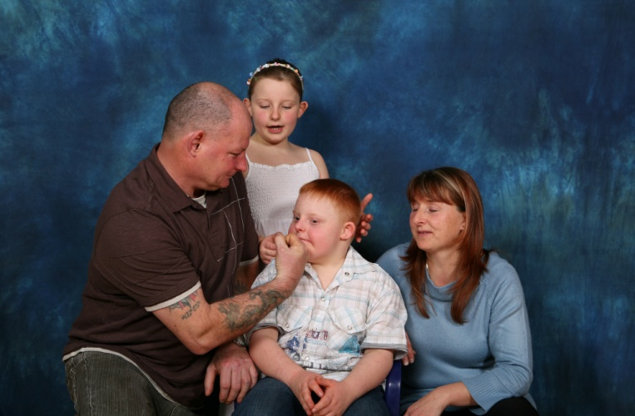

**Managing Behaviour - Some Practical Strategies**

* Everyone concerned with the student (throughout the school…and the family) needs to agree to **act in a consistent manner**, with calm responses and consequences. Always consider these consequences from the pupil’s perspective. Being told off or missing break, for example, may not necessarily be an appropriate sanction for the pupil with DS, as they can find themselves at the receiving end of a lot of attention, which they quite enjoy, and by break time they may have often forgotten the reason for having to miss it anyway. Special treatment or allowances are also to be discouraged. Work closely with the family to ensure that everyone is supporting the same rules.
* **Teach rules explicitly**. Ensure they are understood and reinforced **visually**, using photos and symbols. Children with DS do not pick up rules of social behaviour intuitively, so do not assume that the student will know automatically what is expected of him/her, especially if they are new to the school. Remember that rules (and expectations) might well have been different at a previous school/nursery, so the pupil may well have to unlearn them.
* Don’t take anything for granted. Rather, **make it clear what you expect** of the pupil and praise him/her for getting it right, no matter how small or irrelevant.
* **Provide ways of making choices and having some control** – children with DS can feel that others are always making decisions for them, so giving them some choice makes them feel that they have some control over their lives.
* **Try not to over-support the child**. Give him/her some space. Any special work is much better done in the classroom than in a corridor or side-room. If withdrawal for 1-1 work is really necessary then allow him/her to choose a friend.
* If the child is angry or frustrated, try to find out why – there will always be a reason. In the first instance, **take him/her to a quiet place and give them time and space to calm down**. Time-out chairs can sometimes work. Use an egg-timer to keep them focused and seated.
* **Use short clear instructions**: *“Get your maths book out”* works better than *“Shall we do some maths now?”* and use clear body language – make sure your face is saying what your mouth is saying - *“Good work, Tom”* said with a straight face is not going to mean anything for the student.
* **Be clear and specific when giving praise**. So, *“Good writing!”* or *“Good listening!”* or *“Good walking!”* works better than *“We’ve had a really good morning, haven’t we?!”* Likewise, avoid over long discussions about a particular misdemeanour. After a while the pupil will not pay any more attention to what is being said, but will just agree with what you are saying.
* **Encourage positive behaviour by using visual reinforcement** - prompt cards work well - so that the pupil is reminded of what behaviour is expected before they get themselves into trouble. And reward desired behaviour immediately, with age-appropriate rewards that are relevant to the pupil – sometimes stickers for a fourteen year old are not as appreciated as having extra computer time, for example.
* Pupils with Down syndrome will copy and mimic the behaviour of those around them, whether the behaviour is appropriate or not. So, if the other pupils are walking around the school in an orderly fashion, or lining up in the corridor calmly outside the classroom, then the pupil with DS is more likely to do so too. Likewise, if he/she sees others playing roughly or swearing, then it is not reasonable to reprimand him/her for doing the same, when they may not yet be able to distinguish limits and boundaries. So **place the pupil with good supportive role models** and encourage social interest in them – watch them and talk about what they might be thinking and feeling – and make references about age-appropriate behaviour. Encourage the child’s peers to be supportive and watch out for others’ inappropriate behaviour. Encourage the other children to give feedback to the child instead of telling an adult.
* **Ignore attention-seeking behaviour** (it is intended to distract!) **but give the child plenty of attention when they behave well.** If the child misbehaves make sure you act in an impersonal manner with minimal speech and eye contact. Ensure that no one else gives the child inappropriate attention either. Give lots of attention to another child and then invite the child with DS to join in with you both on condition that they behave properly. Then praise him/her specifically for doing so.
* **Celebrate successes both formally and informally**. Making the pupil aware how proud the school is of him/her will go a long way to raising their self-esteem and eradicating behaviour issues.
* Above all**, establish and maintain a meaningful and warm relationship with the student**. People with Down syndrome are very perceptive and will know whether you like them or not and, like everyone, they need to feel as if they are liked. Taking an interest in what they have got to say, finding books or magazine articles that relate to any hobbies or special interests they might have, and making them laugh will go a lot further than just following policies or procedures.
* Finally**, pick up on early warning signals**. Once a meaningful relationship is established you should be able to recognise and act upon clues and signals which show that something is not right. None of us feel in a good mood if we are feeling unwell or have not had enough sleep, but someone with Down syndrome might not necessarily be able to express adequately how they feel, or even know that they are not well. So, being grumpy or in a bad mood may well be an indication of actually being under the weather. Also, sometimes issues which appear to us as being small or trivial can take on a much greater importance for someone with a learning disability – forgetting lunch money, losing something which they have brought into school, or being embarrassed or disappointed, for example, can bring on feelings of frustration or helplessness which can quickly escalate into uncooperative or defiant behaviour. So, keep a cool head, take the blame or distract if you can, and be sympathetic to the student’s situation. If problems persist, share concerns with the parents and develop a behaviour management plan. Enlist the support of Ups and Downs Schools Advisory Service and the Educational Psychologist. Don’t assume that the child’s needs are best met elsewhere.

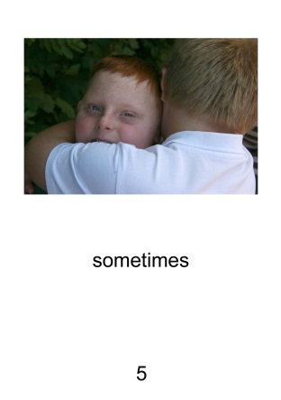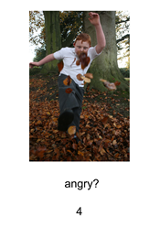

Photos from the book *We Are All Different*, published by Ups and Downs Southwest (email [info@upsanddownssw.net](mailto:info@upsanddownssw.net))

Further Reading

Down’s Syndrome Association:

Children with Down’s Syndrome - Behaviour Information Sheet, Sandy Alton

Down’s Syndrome Scotland:

Making It Work – Supporting Inclusion in Secondary Schools – section on behaviour, Cecilie Mackinnon

Thanks

David Cudworth would like to acknowledge the work of the UK Education Consortium for Down’s syndrome, the Down Syndrome Education Trust and the Down’s Syndrome Association for informing his work and publications.