Friendships and Age Appropriate Behaviour
By David Cudworth
Specialist Advisory Teacher, Ups and Downs Southwest 2011

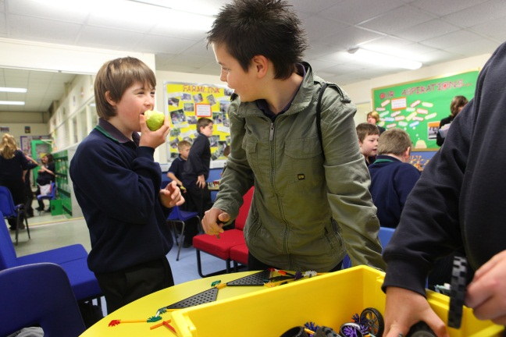
Everybody needs friends, and most early friendships start at school. If the student has attended the local mainstream primary school, they may well be moving up to the secondary school with a good circle of friends already established. It is important, then, that the secondary school bears this in mind when considering the Year 7 groupings, as it is often the case that these are the students who help break the ice in the first few days and weeks of secondary school. They are the ones who already know the student very well and they are often the strongest advocates for inclusion too, because they have grown up with it. So, secondary schools do well to use these students to help overcome the initial barriers or prejudices, either from members of staff: “Actually, sir, Tom is not normally allowed to get away with that.” “That’s a bit easy for Tom, Miss.” Or from the other students: “Tom’s cool.”
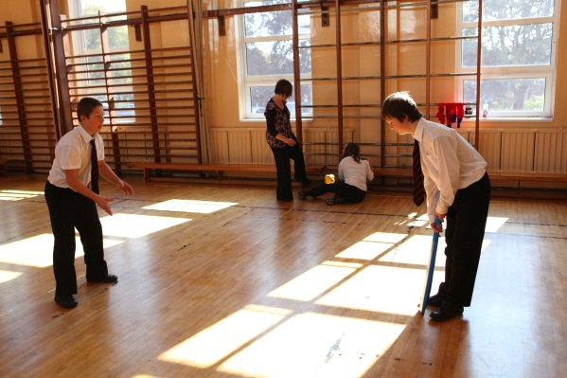
Friendships need active planning and support. Students should be encouraged to befriend and support the student with DS, and they should be rewarded for doing so, either officially or unofficially, with meaningful rewards to recognise the good work they are doing as citizens in a school community. Well-meaning adults often undervalue the degree of friendships between typically developing students and the student with DS, which of course will not be on an equal standing, but which nonetheless can be very fulfilling for the student with DS, and rewarding for the typically developing students. No one is expecting or demanding that the typically developing students become “best friends” with the student with DS, but sharing experiences, doing things together and taking care of each other are all normal expectations for being in a school community. So, give responsibilities to the other students and trust them.
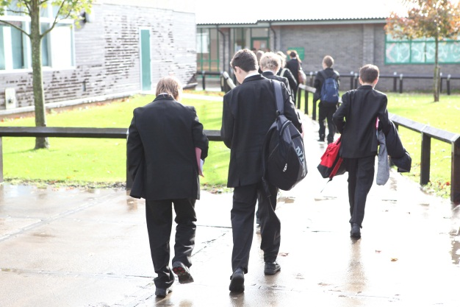

Tom receives low key supervision during unstructured times, such as making his way from one class to another, when he is accompanied by other students.

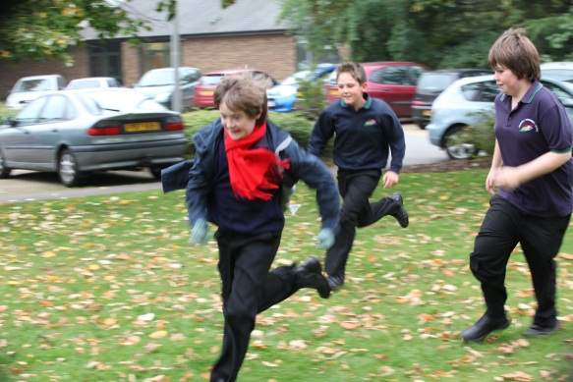
Opportunities to mix with typically developing peers will help the student to develop friendships and learn age-appropriate behaviour. Social skills and confidence are learned in social situations. The student needs, then, to be included in the whole range of school activities where taking part is the most important factor– clubs, drama productions, sports – especially those which play to the individual student’s strengths. Sometimes, a student with Down syndrome is guided to the school library during the whole of lunchtime because the adults have decided that the student prefers peace and quiet, when in fact the student would much rather be given the opportunity to be playing football with his mates, but doesn’t know that he is allowed to. Of course, if you condition a student with Down syndrome to feel more comfortable with their own company or that of adults, sitting quietly reading or playing on the computer, away from their peers, then that is what they will turn out like. Sometimes it is the case that schools choose to direct the student to quiet areas during breaks and lunchtimes because it is easier for them to manage, rather than thinking about what it is the student would really like to be doing. So, take risks – over protection creates over-dependence.

Students with DS tend to be slower to pick things up, learn the rules of social behaviour and learn age-appropriate behaviour, but even though cognitive and language development may be slower than their typically developing peers, they need to be treated with the same expectations. So, the rules and behaviour expected of their peers should equally apply to the student with DS. Students with Down syndrome spend their lives catching up with their peers, but schools do not do them any favours by mollycoddling them or by having low expectations.
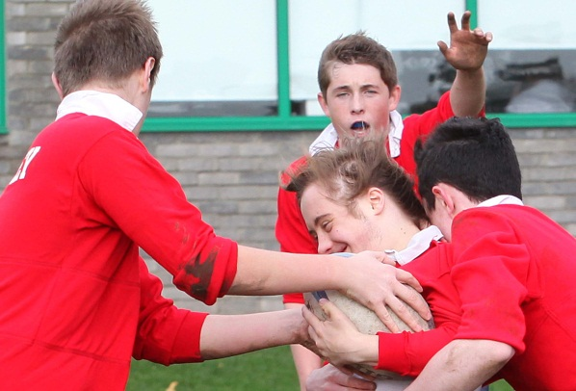

Tom takes part in a lunchtime rugby club.

Talking about disabilities and Down syndrome in particular during school assemblies, PHSE lessons and Circle Time is also a positive move. It gives the students and staff opportunities to discuss openly the issues around learning disabilities, talk about appropriate behaviour and the important role the other students have in setting a good example and being supportive role models. A very good resource for this is the We Are All Different pack, published by Ups and Downs (www.upsanddowns.net).

Thanks
David Cudworth would like to acknowledge the work of the UK Education Consortium for Down’s syndrome, the Down Syndrome Education Trust and the Down’s Syndrome Association for informing his work and publications.

