**Differentiation**

*By David Cudworth*

*Specialist Advisory Teacher, Ups and Downs Southwest 2011*

For a pupil with Down syndrome to be (and feel) included in a lesson, be it in YR or Y11, the top set or the bottom group, the lesson **will** need to be differentiated. For the pupil to feel valued as an equal member of the class, it needs to be the class/subject teacher that does the differentiating; or at the very least there needs to be effective communication in place between the teacher and the TA, so that the TA is aware of the content of the next lesson in order to be in a position to prepare differentiated materials and resources.

If when the pupil and the TA arrive at a lesson, neither of them knows what to expect so that the TA has to differentiate “on the hoof”, the TA’s role becomes compensatory rather than complementary. Ultimately it is the child who misses out.

Attitudes to work can be affected, which can then result in behaviour issues. The blame consequently tends to fall on the child, who is judged to be “difficult”, when in fact they are reacting to an unrealistic situation placed upon them. Teachers need to remember that the child with Down syndrome has a right to be in their class – it is not a gratefully received favour – and it is they, the specialists, who should be taking ownership of the student. It is actually much easier not only to include but also to manage the pupil if the work expected of him/her has been suitably differentiated to meet their needs and levels.

If the work has been suitably differentiated, then the pupil should be able to complete it with relatively little 1-1 support from the TA, which frees him/her up to support other students in the room, or to prepare further resources and differentiated work for future lessons. And differentiation for a pupil with DS is not that difficult to do.

Communication between the teacher and the TA is key. Ideally, there should be some non-contact time each week or fortnight for the teaching and support staff to liaise. Handing the TA the schemes of work and planning at the beginning of each half term will mean that the TA will have a fair idea of what is going to be coming up over the course of the next block of lessons. In this way, too, the teachers demonstrate that they consider the TAs as colleagues. Teaching Assistants are there to support the teacher after all, not just the child, and so the teachers need to value that support.

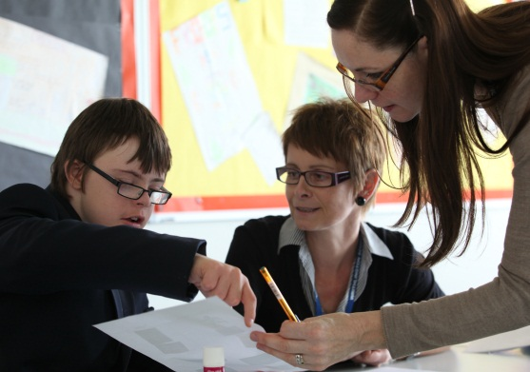

Sam’s TA is copied into each half-termly planning and scheme of work by the Subject Specialists, so that she knows what is coming up. In this way, she is able to prepare visual materials and differentiated worksheets to enable Sam to access the lesson and to record his knowledge and understanding. During the lesson, the teacher checks on Sam’s work.

A knowledge of the learning profile associated with students who have Down syndrome is essential.

**Key Points**:

* Keep it basic
* Keep it simple
* Keep it **visual**

Basically, teachers need to ask themselves the question: **What one thing do I want the pupil to get out of this lesson?** And have that as the learning objective for the pupil. Focus on the child learning one thing well – a single concept or key word is often enough.

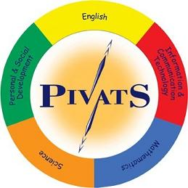In order to differentiate a lesson, teachers need to have accurately assessed the level of the pupil. Then activities can be planned to work towards attaining the next level or target. If the pupil is working at P scale level, then there are two very good resources available: PIVATS , published by Lancashire County Council ([pivats@lancashire.gov.uk](mailto:pivats@lancashire.gov.uk) tel. (01772) 531555), and BSquared ([info@bsquared.co.uk](mailto:info@bsquared.co.uk) tel. 0845 4660141). BSquared also provides assessment tools for assessing pupils who are working at National Curriculum levels (see example below).



Primary Completepublished by The Skills Factory ([www.skillsfactory.com](http://www.skillsfactory.com)) is another resource designed to enable teachers and schools to plan, monitor and assess quickly and automatically. The package also tracks student attainment and progress and monitors curriculum coverage. Although designed initially for primary schools, it is easily adapted to be used with students who have Down syndrome (and many other students) in secondary schools too.

Alternatively, Ups and Downs Advisory Service works with schools and individual teachers in planning a series of lessons and/or scheme of work for their students with Down syndrome. For further information about this service, contact [info@upsanddowns.net](mailto:info@upsanddowns.net)

**Language Difficulties**

Language can often be the greatest sticking point when it comes to the pupil having difficulties accessing the lesson, especially when the vocabulary is complex, abstract or unfamiliar. So, focussing on language acquisition and vocabulary building can be learning objectives in themselves.

The pupils will understand language and concepts much more easily if they are reinforced visually with pictures, diagrams, symbols and readable text. Children with Down syndrome find it harder to understand deeper meanings, and abstract and unfamiliar concepts, so relate language and concepts to familiar and meaningful experiences.

*Example*

*In a KS3 science lesson the students were looking at and recording the effect that adding salt had on the boiling temperature of water. For the student with Down syndrome the focus of the lesson and the learning objective became understanding what the term “boiling” meant, as it was not clear that she did. So, by looking closely at how the water changed appearance the closer it got to boiling point, making a cup of tea, boiling peas, and recording her findings in pictorial form the student understood a new concept and learned a new word, whilst having a direct link to the content of the lesson for the rest of the class.*

**Writing Difficulties**

The vast majority of pupils with Down syndrome will have fine motor, speech and language, short term memory and processing difficulties. These interact with each other and can cause great difficulties in their ability to process, remember, sequence and record information.

However, it is essential that the pupils develop language, thinking, sentence construction and writing as a skill as **independently** as possible, depending on the level of the individual child. One sentence structured and written or recorded as independently as possible is much often more worthwhile than a paragraph of copied words which carries little meaning or understanding.

If concept learning is the object of a particular lesson, then look for ways to record that knowledge other than by necessarily writing it down. Often, the effort required in getting the letter formation right, or staying on the line, or keeping it neat, uses up all of the child’s short term memory and he/she forgets what they are supposed to be writing – the content is lost. So, keep writing as an objective in itself and separate from recording knowledge. Cloze procedure, multiple choice, matching answers to questions are all valid alternatives to writing. Having a words folder (see left) is another very effective resource that many pupils are comfortable with and enjoy using.

The folder opens out to reveal a bank of laminated and velcroed words with which the pupil can then use to build sentences.

Diagram thanks to Cecilie Mackinnon, the Down’s Syndrome Education Consortium

**Some Important Points to Remember**

* Praise achievement in an age-appropriate way.
* Take into account fine motor difficulties and short term memory problems .
* Start simply and build up.
* Have short sessions with plenty of breaks.
* Group the pupil with peers, and use them as support.
* Provide alternative means of recording and lots of visual prompts.
* Focus on the child learning one thing well – a single concept or key word.
* Take into account language difficulties by using simpler vocabulary and providing visual support. Use the curriculum to teach new vocabulary.
* Children with Down syndrome are visual and kinaesthetic learners, so **keep it hands on and visual**.

**Some Common Pitfalls**

* Too much writing expected.
* Too much talking.
* Overloading and multi-tasking.
* Having too low expectations.
* Worksheets which are too busy and too complicated.

**Worksheets**

In preparing worksheets for a pupil with Down’s syndrome the following tips may be helpful:-

* Use meaningful material within or close to the pupil’s experience.
* Introduce new concepts in a familiar context.
* Make the tasks self-contained.
* Provide plenty of visual clues: words, symbols, pictures, diagrams.
* Ensure illustrations tie in closely with text and task. Avoid overuse of writing with symbols.
* If possible try out several different versions of the same worksheet to discover what works best for the individual pupil.
* Leave a wide border all around the edge of the page.
* Highlight and explain key words and any that are new to the pupil.
* Illustrate key words if possible.
* Use type or print, not handwriting.
* Use subheadings to break down and structure the written sheet.
* Use a simple uncluttered layout. Too busy a page causes confusion.
* Break up continuous text. Highlight instructions in some way: in a box, particular font or colour.
* Use coloured as well as white paper, both for variety and to help the pupil distinguish one subject area from another.
* Use simple and familiar language. Keep sentences short and concise.
* Avoid ambiguous words. Use active rather than passive verbs.

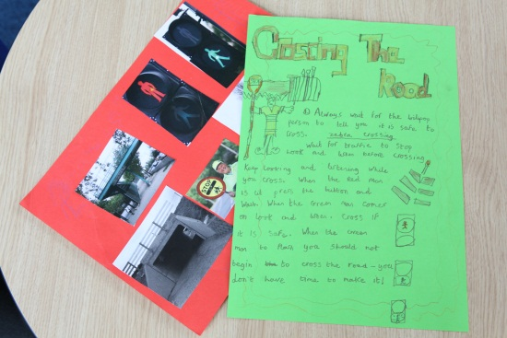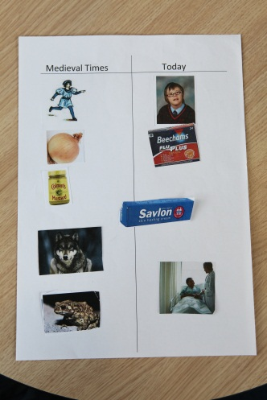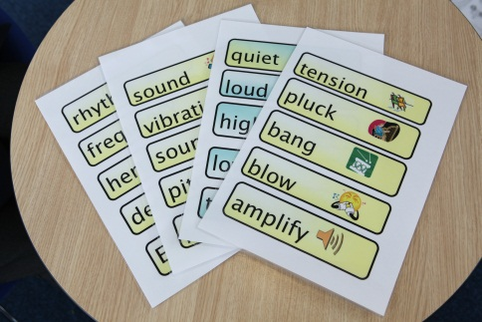

Some examples of personalised and differentiated resources and materials prepared for and used with Sam.