Choosing the Right Classes and Peer Support
By David Cudworth Specialist Advisory Teacher, Ups and Downs Southwest 2011

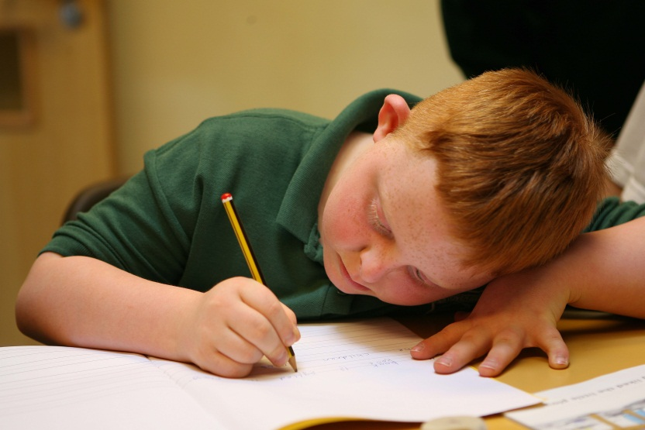
Setting according to ability with regard to the student with Down syndrome needs to be carefully considered. Placing the student in the bottom sets because he/she is the weakest student academically in the year group is not always the easiest or most appropriate option, and actually confuses having a learning disability with having a learning difficulty.

When considering what groups or classes the student with Down syndrome attends, it is important first and foremost to look at the other students who make up the group and judge carefully whether they are going to be supportive role models for the student with DS or not, rather than trying to match the set to the level of the student. Realistically speaking, the lessons are going to have to be differentiated whether the student is in the top set or the bottom group.
Choosing a teacher who is going to be more willing and able to adapt their teaching methods and differentiate the curriculum to meet the needs of the student is an important factor too.

There is no getting away from the fact either that many teachers find it easier to teach the top groups or the mixed ability groups, because they are the ones which tend to have fewer students with emotional or behavioural problems. If a teacher is spending his/her time maintaining order in the class or reprimanding the students, then they are going to have less time to dedicate to the student with DS, and they are going to rely more on the Support Assistant to carry out the differentiation and the delivery of the lesson to the student. In these cases, the TA’s role becomes compensatory rather than complementary, and it is the student with DS who loses out.

It is also important to remember that a big part of the learning profile of students with Down syndrome is that they are visual learners, and as such mimic the behaviour and attitude of those around them. So, if schools want a student with DS who is well motivated and hard-working, then they need to place the student alongside other students who are well motivated and hard-working. If the school places the student with DS in a class where the other students have behaviour issues or who are reticent and have a negative view of school, then they need not be surprised when the student with DS starts displaying behaviour problems themselves.

Furthermore, if the typically developing students have emotional and/or behavioural problems then they are less likely to be emotionally able to be a supportive role model for the student with DS, or they will be more likely to give up. Importantly, too, there is the risk that these students will “set up” the student with DS to misbehave and find it funny when he/she is silly.

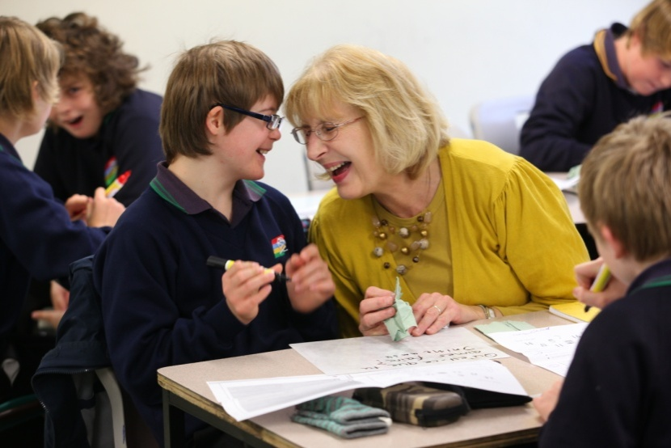

Experience tells us that it is actually easier to manage the student with DS in higher ability sets or mixed ability groupings. A main objective for why a student with Down syndrome, who has a learning disability, is in a mainstream school in the first place, is social integration. Students in higher sets tend to be not only more able, but they also tend to be more mature and, therefore, more easily disposed to being supportive role models for the student with DS.

Also, crucially, the subject teacher has more time to spend directly with the student. Whilst the other students are working on task during the lesson, the teacher then becomes the point of reference for the student, rather than the Support Assistant. The subject teacher spending just 5 minutes of the lesson directly with the student with DS sends out a powerful message: to the student that “I am your teacher and what you are learning here is important, so pay attention”; and to the other students that “This student is in my class and I am now spending time with him/her. So, if you have any questions then you can ask the Teaching Assistant.”

And for many teachers it is immensely satisfying to see how a student learns in a different kind of way, and to realise that what this particular student has learned in this lesson he/she did not know before, and if they have learned it now it is because you have taught it to them. Many teachers who have looked at how they teach and how to present something in a different way, have seen that having a student with Down syndrome has made them a better teacher as a result.

Peer support 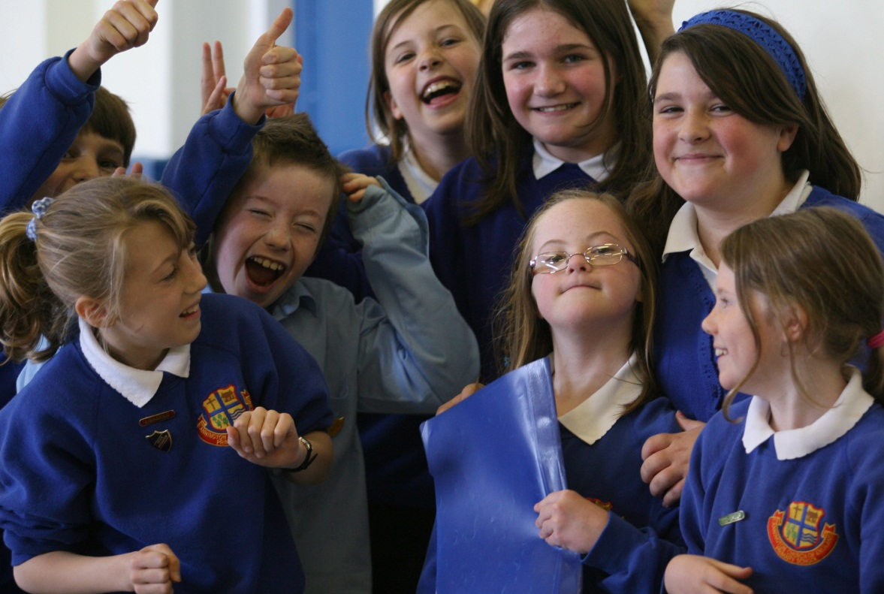

Tom has paired reading sessions twice a week with a sixth-former.

Peer support is an important part of successful inclusion, and it can even be included as part of the school’s PSHE programme of study.

The typically developing students benefit greatly from working alongside and with someone who has Down syndrome, as they develop greater levels of understanding, tolerance and patience. As previously stated, the student with DS will pick up on their attitude and approach to learning.

It is easiest to create periods of peer support during a lesson which is practical and involves group or pair work (pair work does not mean the student being partnered with the TA). The Support Assistant plays an important part here, maybe taking the lead in a group to begin with, showing the other students how they can include the student with DS, and ensuring that the
student does not become too dominant or passive, and then taking a step back. As the students become increasingly used to working together, so the student with DS can become more independent and learn age appropriate working behaviour. Being able to work as part of a group is an important skill the student needs to learn in order to be able to be part of the workforce later on in life, and it is one that they need to be taught directly. They will not learn this skill if they are taught 1-1 in a corridor or side room.

Thanks to Cecilie Mackinnon, Down’s Syndrome Education Consortium

Thanks David Cudworth would like to acknowledge the work of the UK Education Consortium for Down’s syndrome, the Down Syndrome Education Trust and the Down’s Syndrome Association for informing his work and publications

