Speech & Language
By David Cudworth (2011)
Specialist Advisory Teacher, Ups and Downs Southwest,
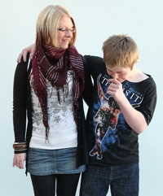
Almost all people with Down syndrome (95%) will have some degree of speech delay, and it is without doubt the biggest cause of frustration for teenagers and young adults with DS.

“Language development is influenced by the quality of social relationships, social opportunities and learning environments… and inclusion – in the family, in the community and in the school – is essential for optimal progress” ( Prof. Sue Buckley).

Research* has shown that students who have gone through mainstream education have a much wider vocabulary and much clearer speech than those who have gone through special provision. Intervention during the early years pays dividends when the child reaches adolescence and there is no limit or ceiling to vocabulary acquisition. However, despite more and more research into the speech and language development of children with DS and greater advances in speech production and clarity with each generation that passes, today’s generation of young people with DS will still have speech and language issues which may have an impact on their self-esteem.

Language underpins cognitive and social development for all children. Any child with a language delay will have some degree of cognitive (mental) delay. Not being able to express yourself as you would like makes you appear to be less able than you actually are and, crucially, sets you apart from your peers.

We use language for:

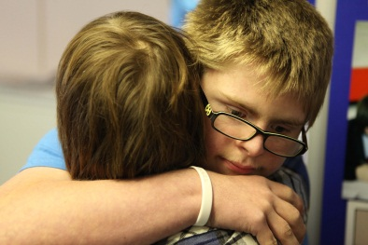
- knowledge (which is affected by vocabulary size).
- remembering, thinking and reasoning.
- self-control and planning.
- dealing with emotions and worries.
- communicating with others.
- And we use language for friendships.
Talking requires clear speech skills.

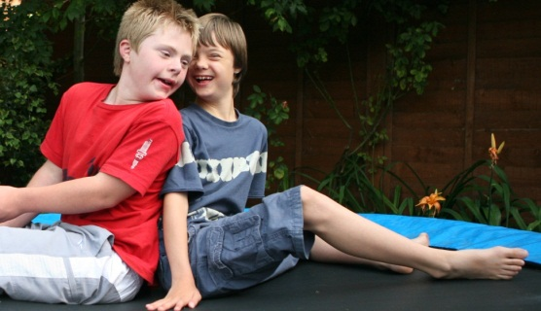
Children with Down syndrome go through the same stages of learning as typically developing children, and this is true also of language acquisition, but it is true to say that they tend to reach each stage at a later point in their lives and they tend to stay there for longer.

The stages of development for speech and language are:

- Non-verbal skills for commenting, requesting, answering - starts with looking, smiling, pointing.
- Then words – vocabulary learning and working out meanings then saying the words.
- Then sentences – grammar learning and stringing words together for more complex meanings.

For most children with Down syndrome spoken language is delayed for mental age but they show an uneven profile.

- Communication skills are usually good.
- Vocabulary is delayed but grows steadily – receptive language tends to be better than expressive language (ie. their understanding is ahead of their expression).
- Grammar is more difficult – they can tend to be “telegraphic” speakers.
- Clear speech is more difficult and this means that speech is more difficult to understand.

At an age when appearance and attitude are of key importance, the teenager with DS can find it increasingly hard to keep up with the latest social trends and colloquialisms, and if you don’t talk like everybody else, you will not be talked to in the same way. Also, as the typically developing students get older and become adolescents themselves, they will need to be encouraged to continue to be supportive to their schoolmate with Down syndrome. A consequence of full inclusion in mainstream education is higher achievement and better social progress, yes, but along with that comes an increased awareness on the part of the student with DS of the differences (academic and social) between him/herself and their typically developing peers. It is paramount that schools deal with this area of school life with great sensitivity.

Intervention during the early years pays dividend when the child reaches adolescence. Speech and Language Therapy input is essential – we recommend at least six times a year. However, the SLT needs to know the implications involved with having Down syndrome and SLT intervention is not enough on its own! Families and schools need to be proactive in giving the children as many opportunities as possible to improve the quality and quantity of everyday communication, so that they learn the language relevant not only for the curriculum but also for emotional, social and leisure needs. Targeted focussed language activities will need to be continued throughout their schooling (according to the level of development of the individual). However, a willingness to listen and show interest in what the pupil has to say is the most important thing that teachers, TAs and other pupils can do to help.

Some practical suggestions

- Teach the child to read.
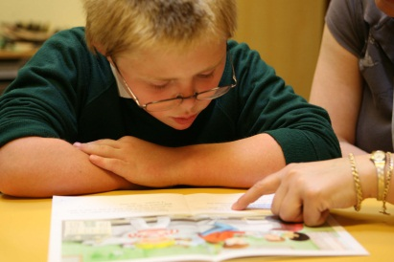
Children with Down syndrome who are good readers tend to be good talkers and teaching reading early (2-4yrs) results in greater language gains later on. 10% of children with DS read at age-appropriate level and most achieve 7-8yr old equivalent. They tend to use visual learning strategies for longer than other children- they read words by sight for longer and they use phonics later. Reading comprehension tends to be better than listening comprehension. Learning to read improves not only speech but also working memory. Furthermore, reading helps the pupil realise that sentences exist, so do plenty of reading, as well as story/fact recall and role-play sessions. There is a recommended methodology for teaching young children with DS to read – See-and-Learn (produced by DownsEd International and free to download from their website www.dseinternational.org) – which uses the children’s strong visual learning skills and matching, naming, choosing and selecting when teaching them to read.

- Language can often be the greatest sticking point when it comes to the student with Down syndrome having difficulties accessing a lesson, especially when the vocabulary is complex, abstract or unfamiliar. So, focus on language acquisition and vocabulary building as learning objectives in themselves when differentiating lessons. The student will understand language and concepts much more easily if they are reinforced visually with pictures, diagrams, symbols and readable text. Students with Down syndrome find it harder to understand deeper meanings, and abstract and unfamiliar concepts, so relate language and concepts to familiar and meaningful experiences.

Example

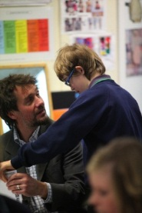
In a KS3 science lesson the students were looking at and recording the effect that adding salt had on the boiling temperature of water. For the student with Down syndrome the focus of the lesson and the learning objective became understanding what the term “boiling” meant, as it was not clear that she did. So, by looking closely at how the water changed appearance the closer it got to boiling point, making a cup of tea, boiling peas, and recording her findings in pictorial form the student understood a new concept and learned a new word, whilst having a direct link to the content of the lesson for the rest of the class.

- Listen carefully. Your ear will adjust to his/her speech.

- Take the blame for not hearing or understanding what the child has to say, or blame the background noise. This will help take the pressure off someone who may be sensitive to failure and to the reactions of others.

- Give choices (“Would you like to drink juice or milk?”) and use open-ended questions (“Tell me more…”).

- Make life difficult! Try not to do everything for them; instead put things out of their reach, so that they are obliged to ask for things (from peers initially) and to leave the room, in complete sentences.

- Respond to all attempts at speech and model speech for the child to imitate.

- Give the child extra time to take in what has been said and to respond. Try not to “speak for them”.

- Get the pupil to read back what they have written, or to read the sentences they have formed during ordering or sequencing activities.

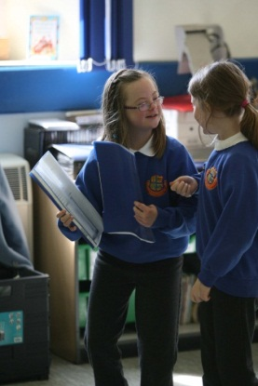
- Give the pupil as many opportunities to speak as possible. Give them jobs and responsibilities, such as handing out books, worksheets, taking the register/a note to the office etc. This will not only raise their profile in the class and in the school, but it will also give them further opportunities for positive social interaction: “Hello. How are you? Here you are.” Responsible peers can be partnered up with the pupil for this, as well as/instead of a TA.

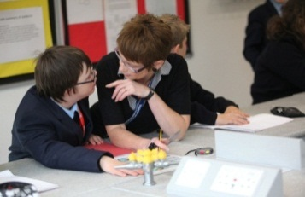
- At secondary level, use topic webs and visual mapping to help him/her to speak aloud to an audience without resorting to reading long passages. A good software package for this is Communicate: Ideas by Widgit (www.widgit.com).

- Many students may need to be reminded to slow down their rate of speech, relax and breathe properly while speaking.

- And, of course, establish a meaningful relationship, maintain eye contact, and show an interest in what they have to say.
Outcome data* from a study of teenagers shows significant gains in spoken language as a result of comprehensive interventions from early years. Research has shown that immersion in mainstream schools results in significantly better reading skills and thus in significantly better language and clearer speech.

Schools can make a difference!

* (from DownsEd 2009)

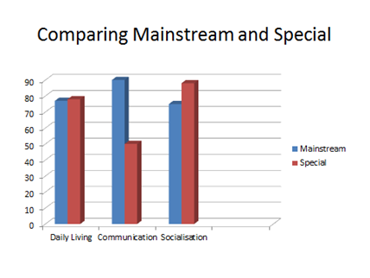
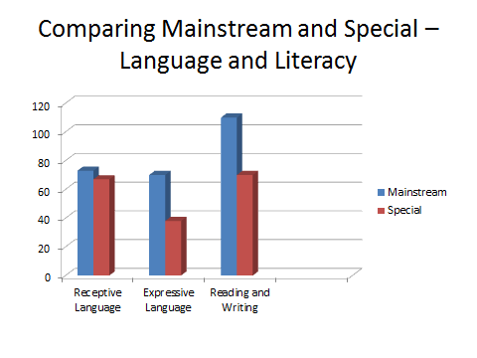

Thanks
David Cudworth would like to acknowledge the work of the UK Education Consortium for Down’s syndrome, the Down Syndrome Education Trust and the Down’s Syndrome Association for informing his work and publications.

