Ups and Downs Southwest, The Old School, School Road, Westonzoyland, Somerset TA7 0LN
Tel 01278 691100 Email: info@upsanddowns.net

Using a Visual Timetable

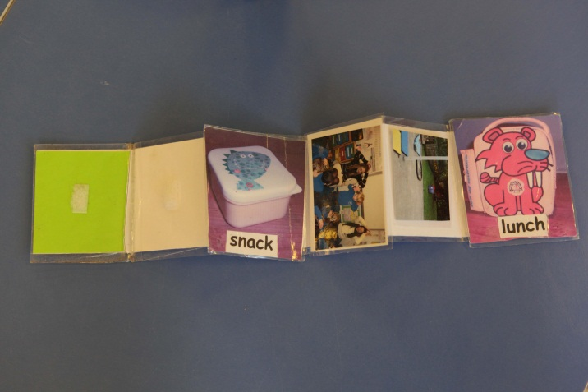

By David Cudworth
Specialist Advisory Teacher, Ups and Downs Southwest 2011

Many children with Down syndrome have a shorter concentration span than their peers. They also tend to have short term memory issues, which means that they often forget what has been said earlier on in the day or lesson. They will definitely be helped to understand the routine and structure of their day through the use of a visual timetable.

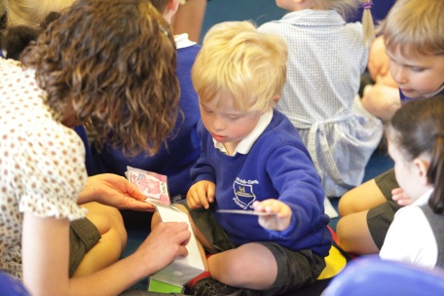
A visual timetable works best when it is used as a working tool with the child. Rather than having it stuck on the wall or just introduced first thing in the morning, it needs to “belong” to the child and referred to continually throughout the day. It is important that the cards on the visual timetable are labelled photos of the child him/herself rather than abstract pictures or symbols, which can hold little relevance or meaning for the child with Down syndrome: a photo of his/her own lunchbox or the child seated on the carpet alongside his/her peers are much more effective than an abstract picture representing lunch or stick people sitting down, for example. As each activity is completed, the child can pull off the card and be directed to go on to the next activity. Use the visual timetable to encourage speech and language and as a sequencing tool too, using vocabulary and phrases such as, “What’s next?” and “After that what have we?” In this way, the child is much more likely to feel as if they have ownership of their day, with fewer surprises, and that they have had some part in choosing what to do. These children can feel as if they have their whole lives decided for them and they (quite rightly) can object to that, often in the form of avoidance strategies or by being “stubborn”.
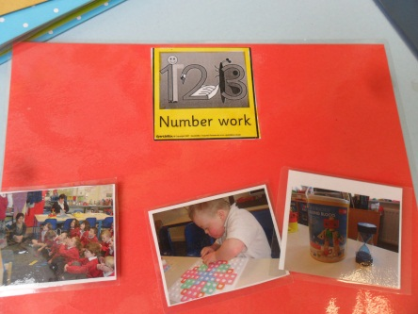
Likewise, make a mini visual timetable for individual lessons, so that, for maths for example, the child has the maths picture at the top of the card, and then a velcro strip with pictures showing the order and the structure of the lesson (carpet time – table work – reward, for example). In this way, he/she can pull off each part of the lesson, and see themself getting closer to the reward and end of the lesson. This might help to keep their concentration going.

Part of being in a mainstream school is for the child to develop in their independence and self-learning skills. Using a visual timetable in this way helps the child to become more independent and less reliant on being told what to do all the time.

Thanks
David Cudworth would like to acknowledge the work of the UK Education Consortium for Down’s syndrome, the Down Syndrome Education Trust and the Down’s Syndrome Association for informing his work and publications.

