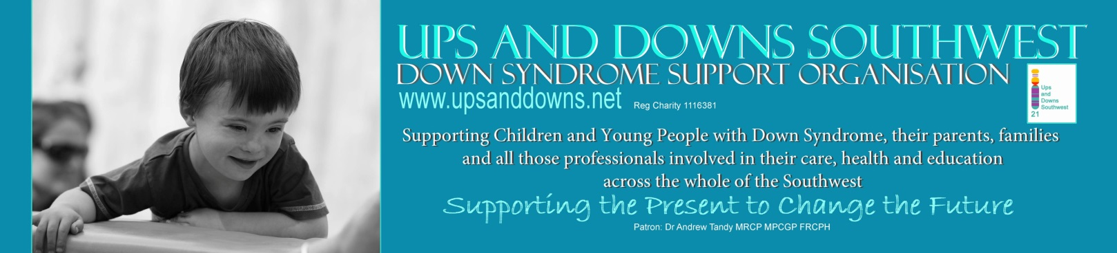
Ups and Downs Southwest, The Old School, School Road, Westonzoyland, Somerset TA7 0LN
Tel 01278 691100 Email: info@upsanddowns.net

Useful Apps

Special Words:-

With a simple and intuitive interface, Special Words has been shown to be accessible and hold the attention of children with Down syndrome, autism, poor fine motor skills, hearing impairment and other learning difficulties, as well as being appealing to typically developing children. For those who are unable to use a touch screen, but who can operate assistive switches, the app can be used with 1 or 2 Bluetooth-connected switches.

Special stories:-

You can use Special Stories in many ways, including:
-Making photo albums about vacations, trips, and other events.
-Improving reading skills
-Encouraging development of spoken language skills
-Creating talking books
-Helping with social skills
-Explaining step-by-step tasks
-Practicing foreign language skills
-Sharing information between home and school
-Sharing news with distant family and friends
You can create as many stories as you wish, and update them again later. Each story can have any number of pages, and each page can have a photo (or any other image), up to 30 seconds of sound you record, and several lines of text. A choice of large and small text sizes, in an easy to read font, allows for either single words and short phrases or longer sentences.
Special Stories has a simple and uncluttered interface for reading and listening to stories, making it suitable for use by children and adults with ASD, Down syndrome, poor fine motor skills, hearing impairment and other learning difficulties. For those who are unable to use a touch screen, but who can operate assistive switches, the app can be used with 1 or 2 Bluetooth-connected switches.

Sentence maker:-

Sentence Maker is an exciting interactive game that helps your child rapidly learn to make and complete their own sentences all with just the touch of their finger. The interface is so easy to use that even a 9 month old baby will delight in moving their first words around the page. Ideal for ages 1 to 6

Splingo:-

An exceptionally high-quality, interactive game designed by Speech and Language Therapists/Pathologists to help children learn listening and language skills.
With thousands of different word and sentence possibilities, Splingo the alien’s spoken instructions will guide your child through a galaxy of language learning.
Your child will practise their listening and language skills by interacting with the images and animations on the screen to follow Splingo the alien’s spoken instructions. As a reward, they will love helping Splingo build a space ship and complete the tasks in order to get him home. His hilarious animated responses will capture your child’s imagination.
Splingo’s instructions range from a very early level of language development, e.g. single word recognition, to much more complex, e.g. instructions combining several aspects of language at once.

Fab-Phonics "Road block":-

Containing over 75 words, with colourful illustrations and sounds, The Fab-Phonics 'Road Block' is designed to help teach young children to read. It's fun, easy-to-use and focuses on building fluency in reading and spelling simple, three letter, consonant, vowel, consonant words.
What makes this app different?
–It's versatile
–Easy-to-use, even for little ones
–Child/Parent/Teacher friendly
–Features engaging and fun characters, with lively sound effects
–It's an exciting game that makes learning fun
–It's been tried and tested by children, parents and experienced teachers
-The full version contains over 75 words, with matching illustrations and sounds (15 words included in the Lite version)
-Phonics sounds produced by leading UK educational consultants

Hairy Letters:-

Learn the names and sounds of each letter with the Hairies.
AWARD WINNING APP! EDUCATION RESOURCES AWARD.
• Interact with animations and trace the letter shape onscreen with your finger.
• Play games to reinforce learning and build letters into simple words.
• Letter sounds come to life with animated characters.
• Learn to form each letter shape with your finger.
• Play games to blend letter sounds into first words.
• Includes upper case letter names.
• Multisensory learning by UK specialist teachers.
• Letters are introduced in six colour-coded stages

Special Numbers:-

Special Numbers contains a set of activities to help develop early number skills, including counting, matching, ordering, comparing and selecting. We have designed the app in collaboration with parents, children, teachers and educational psychologists, and with reference to research into how children acquire mathematics skills.
All the activities are intended to be accessible and hold the attention of children with learning difficulties including Down syndrome, autism, poor fine motor skills and hearing impairment, as well as being appealing to typically developing children. Special Numbers is suitable for use at home, at school, in nursery or kindergarten, and in therapy sessions.
There is no set order to the activities in this app, and each activity is highly configurable, so you can address a particular skill at the child’s level whenever you want, and continue to use the app as their abilities develop. Settings you can change include:
• Range of numbers (between 0 and 20, depending on activity)
• Objects to use (digits, words, balls, animals, clocks and dominoes)
• Fonts (including our own font with easy-to-read digits and letters)
• When and where to use the built in sounds
• Speed of animations (to adjust the pace of the activities)
Special Numbers includes some pictures from the See and Learn Language and Reading resources published by Down Syndrome Education International. These will be familiar to children who have used the paper-based See and Learn activities, or our Special Words app (which also uses these pictures).

