Why Inclusion?

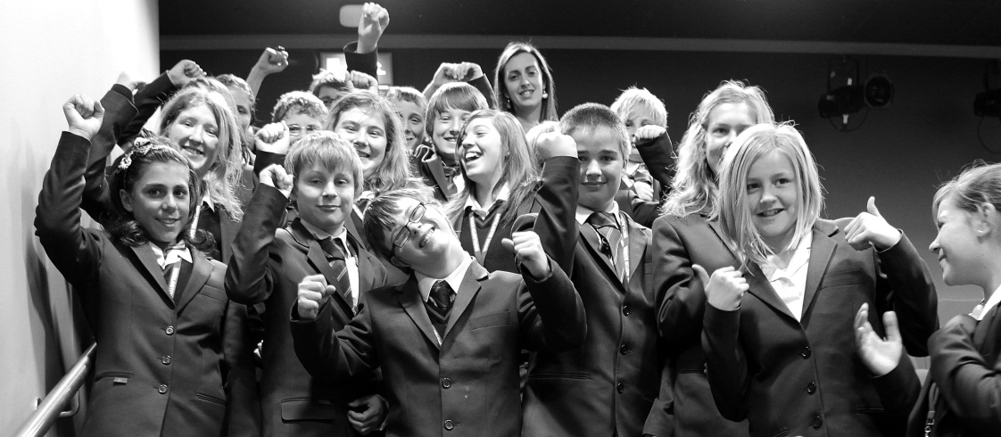

Politically speaking, students with Down syndrome belong to their local mainstream secondary school. Having gone through mainstream primary school and established friendships there, it is only natural that they should move on with their friends to their local secondary school, where they are recognised by themselves and others as valued members of the school community and the local community. This is a basic human right and not a gratefully received privilege.

Teachers constantly tell us of the benefits of inclusion and how the pupil with DS has made the school a better place. One local primary head teacher recently stated at an annual review that in the 25 years that she had been head teacher at that school, she had never encountered a class of children as caring or altruistic as this particular class, and it was down in large part to having the child with Down syndrome in it.

Essentially, inclusion promotes better tolerance, patience and understanding of people with disabilities, and it helps to eliminate prejudice in society as a whole. Inclusion is not just for the child with a disability. The typically developing children benefit a great deal too: they do not patronise their classmate, they become less competitive and more supportive of others, they learn to appreciate diversity, and they learn that everyone’s contribution is of value and is important to the life of the school.