Successful Inclusion
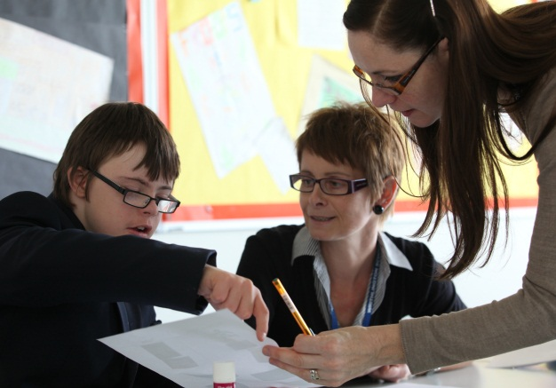
Key factors:

- Attitude of the school.
- Support and training for staff.
- Behaviour of the student.
- Ability of the student.

Experience tells us that, in order for inclusion to work, there has to exist first and foremost a willingness to make it work on the part of all those concerned. The receiving school needs to have a positive attitude, a flexible approach, and accept that meaningful inclusion will require some changes to the status quo. These need not require whole school upheaval, but rather small changes which will make the school that bit more accessible to the student and make his/her time there easier for them.

Difficulties are viewed as challenges, that can develop teaching skills, and not as obstacles preventing inclusion. “It is a professional duty for a teacher to meet a child’s needs, not an option” (Sue Buckley).

But, teachers and support staff cannot successfully include a student with Down syndrome without additional training, and support from the senior management of the school. Knowing that you are not on your own in having to deal with an unfamiliar situation and that you are supported by the senior management and by outside agencies such as Ups and Downs Southwest is essential.

Other key factors to successful inclusion are, without doubt, the behaviour of the individual student, and the ability of the individual student. There is no getting away from the fact that by far the majority of successful secondary school placements are those where the student has fewer behaviour issues and where he/she has been more able to cope with the demands of the secondary school curriculum. When the student has started to display behaviour problems, then schools have been known to give up and start to become less positive towards inclusion. And schools tend to find it easier to include a student who is more able than to include a student who is less able.

However, many incidences of behaviour problems are caused by an inflexible system rather than by the student directly, and many students can find it hard to cope with work that has not been appropriately differentiated.

