Social Success
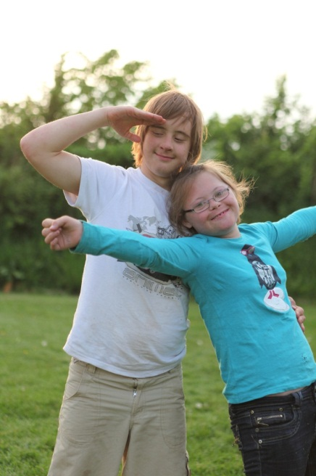

Teenagers with Down syndrome need explicit teaching on how to have happy, healthy relationships. They will go through the same physical and emotional changes during puberty as any teenager, but they will not know necessarily how to handle those changes appropriately or understand feelings and emotions.

They will need to be helped to get things right and how to be safe, so that they do not put themselves into positions of ridicule or embarrassment. They will need guidance and reminding about personal hygiene, keeping clean and looking good.

Teaching them about what kind of behaviour is appropriate in private and in public is paramount here, especially when the school cannot take it for granted that the student knows where is private and where is public!

There are complete educational packs available which have been created to teach SRE (Sex and Relationships Education) to teenagers with learning disabilities, such as the Jiwsi pack (www.fpa.org.uk) and The Confidence Factor (written by Sarah Duigan and published by Image in Action, www.imageinaction.org tel. 01494 481632), and schools would be strongly advised to have in place a programme of study to pre-empt any inappropriate behaviour. It is always important to bear in mind that, if a student with DS does exhibit inappropriate behaviour, it will almost certainly not be his/her fault. Rather, it will be due to a lack of awareness, or even copied behaviour that they have seen elsewhere.

Again, using peers as supportive role models, is key here. A teenager with DS is more likely to take advice about what is “cool” or “not cool” from an older role model or peer whom they look up to, than from a well-meaning adult.

Specialist outside agencies, such as Ups and Downs Southwest, can provide training on how to implement an SRE programme and there is a wealth of information and resources out there for schools to access. For information about training or resources contact info@upsanddownss.org .

Further Reading:

The Confidence Factor
Sarah Duiga, published by Image in Action, www.imageinaction.org tel. 01494 481632

Jiwsi, A Pick ’n’ Mix of Sex and Relationships Education Activities
Mel Gadd and Jo Hinchliffe www.fpa.org.uk

Sex and Relationships Education for Children and Young Adults with Learning Difficulties
Sex Education Forum (www.ncb.org.uk/sef)

