Objectives of Inclusion

The student will:

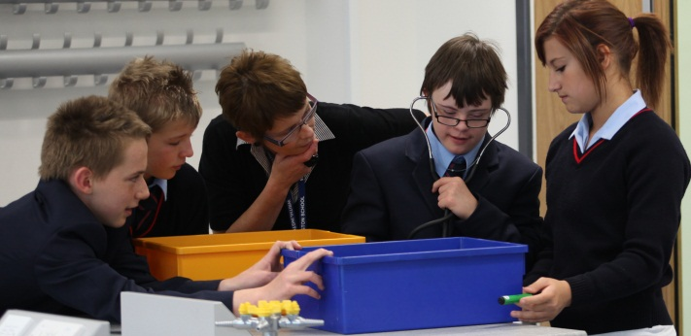
- Gain new skills.
- Develop age appropriate behaviour.
- Develop independent learning behaviour.
- Develop friendships in the community.

Some secondary school teachers ask the question: Why is this student coming here, rather than to the special school, where their needs will surely be better catered for?

“It is easier to adapt the curriculum to meet the needs of students with Down syndrome and their specific learning profile in a mainstream school rather than in special provision.” (Prof Sue Buckley, DownsEd)

Research has shown that, comparing like with like, teenagers with Down syndrome who have gone through mainstream schooling show better progress academically and socially than their corresponding peers educated in special schools*: they are more than two years ahead in their spoken language, more than three years ahead in reading and writing, and they show considerable gains in maths skills. They are also more included generally outside of school and display fewer behaviour problems. This is despite mainstream schools having larger class sizes and “less specialised” teaching staff. The answer lies, in our experience, in holding high expectations for academic achievement and for age appropriate behaviour.

There are examples of successful special school placements, but what the students with Down syndrome get from attending mainstream classes is access to more challenging work and, most importantly, they witness and learn age appropriate behaviour and language from typically developing role models. They also have more opportunities to develop friendships in their local communities, alongside their peers and siblings. Teenagers and young adults with Down syndrome who have gone through mainstream schooling will meet people in their local community who know who they are and who may even have been at school with them. They do not get these experiences if they have been bussed across town or county to the special school there.

*Prof Sue Buckley, Down Syndrome Education Conference 2009

Main findings of the study:

- No progress from 1988-2000 for special class outcomes
- Significant and specific educational benefits for inclusion
- Teenagers fully included in mainstream classes:
- Showed gains of more than 2 years in spoken language skills and 3 years in reading and writing
- Showed gains in maths, general knowledge and in social independence
- Showed no differences in personal independence or social contacts out of school
- Tended to have better behaviour.

See Appendices for graphs and data.

