Into Key Stage 4

During Years 7-9 the student should be accessing all subjects, with lessons differentiated using curriculum mapping and clear visual resources. As the student makes their way through the school into Key Stage 4, many schools realise that their options for including the student actually get wider and the provision can become more flexible.

Schools find it easier to manage the student by creating individualised programmes of learning that are relevant to the needs of the student, preparing the student for life after school, in college or employment.

As the typically developing peers consider their GCSE options towards the end of Year 9, schools should look at the student’s individual strengths/interests and choose the subjects that match these, in addition to continuing to teach basic skills in literacy and numeracy, and developing independence and self-esteem. Many students with Down syndrome have been able to achieve GCSE results grades C-G in the subjects they are particularly strong or interested in. Others have been able to attend GCSE courses and attain alternative accreditation, such as Entry Level GCSE, BTEC, or NOCN (National Open College Network) qualifications. In some circumstances it may be appropriate for schools to award students with their own accreditations, as long as these formally and clearly state what the student is capable of and with what support. Matching the curriculum to the needs of the student at KS4 should be part of the school’s continued approach to inclusion. It is not acceptable for the student to attend a course and receive no accreditation at the end of it. Students can then take all their awards and qualifications along to interviews with prospective colleges or employers, where they can be used to promote the student’s individual strengths.

In this respect, schools need to put in as strong a recommendation for the student as possible with colleges and employers, and staff need to work with the student’s often strong social skills to coach them to perform well at interviews. In doing so, schools will enable their students who have Down syndrome to access a far wider choice options on offer at college. Some schools have provided their students with a detailed portfolio or record of achievement which has been used by the students to present their strengths with confidence at interview.

In preparation for college or employment, schools should endeavour to forge strong relationships with colleges and training providers, through the student spending one or two days a week doing work experience or attending interesting and worthwhile college courses. It is no longer acceptable or appropriate for schools or colleges to consider SEN courses, such as “Learning for Living” or “Life Skills”, as appropriate options for the vast majority of students with Down syndrome, where they find themselves grouped with other SEN students, who often have greater needs and disabilities than they do.

Someone who has gone through mainstream education successfully all their life will not want to find themselves at fourteen or sixteen with fewer options open to them than their friends and peers. Being able to access the same range of courses that are available to all students is a basic human right, and the measures brought in under the Disability Discrimination Act (DDA) apply equally in the areas of employment and FE provision. For more detailed and extensive information on how to enable students with DS to access and be included in FE colleges, consult the resource Education Support Pack for Further Education published by the Down’s Syndrome Association.

Case Study

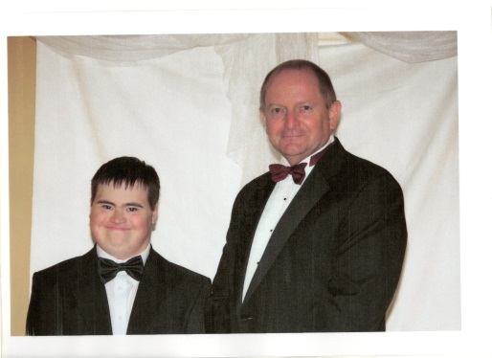
The Blue School, Wells, and Crispin School, Street – student: Callum Stevenson

The Blue School teamed up with other schools in the county, and particularly with Crispin School in Street, in forming a Link Group based at Crispin School.

Callum and the Head of The Blue School,
Steve Jackson, at the School Prom

The Link Group was originally set up by Crispin Secondary School in Street, Somerset, and Avalon Special School, also in Street.

The idea of the two Head teachers, the Link Group was created originally for students at both schools, to give them access to specialist teaching within a mainstream setting. It then grew to include students from other mainstream and special schools, one of whom was Callum.

Crispin School provided a classroom (including furniture and heating), a mini-bus and £15.000 a year to finance teacher input. It also provided students who would benefit from the specialist teaching for two days a week. Avalon Special School provided the teaching staff and the students it considered would benefit from spending two days a week in a mainstream setting. Other schools, such as Callum’s school, had the opportunity to purchase a place in the Link Group, putting in 2/5 of the funding the school receives for the individual student (the equivalent of 2 days for each school week).

From having started out as one small Y10/Y11 group, the Link Group grew into two separate groups (one for Y10 students, one for Y11) of around 12 students in each. The teachers and the SENCOs from all the participating schools worked together on the planning the curriculum and reporting.

Although the students followed a specific academic programme, the aim of the Link was also to enable the students to form lasting friendships. It was this that made the Link Group really stand out, as many of the students, including Callum, started meeting up outside of school.

In Year 11 the students spent one day a week at Crispin School, and the other day out at the Crocker’s Centre, Cannington, which is part of Bridgwater College.

While in class at Crispin School, the students worked on core skills in literacy and numeracy, as well as on topic work. Expectations were high and there was a very strong work ethic within the group. This was down to the fact that the teachers tailored the curriculum to meet their needs and their interests.

At the Crocker’s Centre, Callum’s Year 11 Group accessed many of the facilities and courses that the college had to offer: animal care, horticulture (there is a very large greenhouse and a walled garden), art, DT, and Food Technology, amongst others. It was through accessing the facilities and resources at Cannington that Callum decided he would like to go to college there.

Callum’s achievements from the different courses he attended, both at The Blue School and at the Link Group, were formally recognised through the use of his Progress File – a summative document which offered prospective employers and colleges information about Callum. He was able to take along his Progress File to a two-hour interview at Bridgwater College, where was subsequently offered a place on the Animal Care course in Cannington.

Further Reading

Education Support Pack for Further Education
The Down’s Syndrome Association, 2009

Alternative Accreditation at Key Stage 4 Information Sheet
Sandy Alton, The Down’s Syndrome Association

